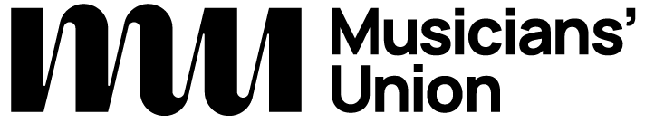

Access Rider
for disabled musicians, performers, artists, composers, educators, and technical staff in venues

Please do not share this document without my prior consent
Introduction
My access needs

Emergency information
Further information

Find out more about how to use the Access Rider template along with examples and alternative formats: theMU.org/accessrider.

